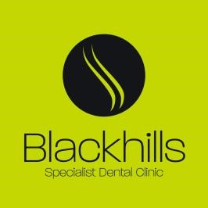

Advice For Patients With New Implant Crowns and Bridges

- You should expect the new teeth to initially feel a little strange in your mouth and your tongue may be very aware of the new shapes. This is a normal feeling at this time. The mouth is extremely sensitive to new changes and it usually takes at least 2 weeks to adapt to the new teeth.

- You may also notice that your speech is a little different. Again, this should settle as you adapt to your new teeth. If you have been wearing a temporary denture it may take longer for the tongue to adapt to the new shape and for the speech to fully settle.

- The implant teeth may initially be cemented with a very soft cement to allow an initial assessment of the restoration. Please do not eat foods that are too hard or chewy for the first week. Should the crown or bridge come loose then please contact the surgery. However, in an emergency, a denture adhesive such as poly grip could be applied to the fit surface of the crown or bridge before repositioning it. This is usually adequate to keep the tooth or teeth secure until we can see you.

- It is absolutely critical that you continue to keep your teeth and mouth extremely clean. This will help the implants to last as long as is possible. Please clean your own teeth and the implant teeth thoroughly twice a day. This may require the use of new brushes or special floss. We may advise a visit to the hygienist to help with this. If you are struggling with the new cleaning aids then please do ask for help.

- You should be able to eat a normal diet. However, we would ask you to avoid very brittle foods such as boiled sweets. Apples and carrots are not a problem.

- If your restoration is screw retained, then there will be a small tooth coloured filling in the screw hole access. It is possible that from time to time these fillings may come out. Your own dentist should be able to replace these but must ensure that the screws are protected with cotton wool or PTFE tape. Your dentist is welcome to call for advice should he or she need it.

- It is essential that you continue to see your own dentist for routine check ups and treatment. We also advise that you see a hygienist at least twice a year.

Should you notice any pain, swelling, bad taste or looseness, then please contact the clinic for a review appointment.

Blackhills Clinic - New Implant Crowns and Bridges – Patient Information
October 2020 For review October 2024

